**LIFELINE**

**BLOOD BANK** **DATABASE**

**MANAGEMENT SYSTEM**



**THE AIM OF A PROJECT**

**Blood bank database management is to create a comprehensive and efficient system that manages the storage, retrieval, and dissemination of information related to blood donations, inventory, donors, recipients, and other relevant data within a blood bank or blood donation center. Here are some specific objectives or goals that such a project might aim to achieve:**

**Efficient Blood Inventory Management:** Develop a system that tracks the inventory of different blood types, quantities available, expiration dates, and storage conditions to ensure an adequate supply of blood at all times.

**Donor Information Management:** Create a database to store information about blood donors, including personal details, medical history, donation frequency, and contact information.

**Recipient Matching:** Implement a system that matches blood donors with recipients based on compatibility of blood types and other medical criteria.

**Security and Access Control:** Ensure data security and implement access controls to protect sensitive donor and patient information in compliance with privacy regulations

**User-Friendly Interface:** Design an intuitive and user-friendly interface for both donors and blood bank staff to easily input and retrieve information.

**User-Friendly Interface:** Design an intuitive and user-friendly interface for both donors and blood bank staff to easily input and retrieve information.

By achieving these aims, the project aims to streamline the operations of the blood bank, enhance the efficiency of blood donation processes, improve donor and recipient experiences, and ultimately contribute to saving lives by maintaining a steady and accessible blood supply for those in need.

ER DIAGRAM

**RECEIVER**

**receiver_id,**

**receiver_name,**

**gender,**

**age,**

**address,**

**state,**

**blood_group,**

**b_id,**

**contactno,**

**receiveing_date**

RECEIVE BY

DONATE

**BY**

**BLOOD TYPE**

**Blood_id,**

**Blood_type**

**DONAR**

**donar_id**

**donar_name,**

**gender,**

**age,**

**contactno,**

**blood_group,**

**address,**

**state,**

**date_0f_donate**

**TABLE DESCRIPTION:**

**Blood type:**

+------------+-------------+------+-----+---------+-------+

| Field | Type | Null | Key | Default | Extra |

+------------+-------------+------+-----+---------+-------+

| blood_id | int(11) | NO | PRI | NULL | |

| blood_type | char(5) | NO | | NULL | |

+------------+-------------+------+-----+---------+-------+

**Receiver:**

+----------------+--------------+------+-----+---------+-------+

| Field | Type | Null | Key | Default | Extra |

+----------------+--------------+------+-----+---------+-------+

| receiver_id | int | NO | PRI | NULL | |

| receiver_name | varchar(20) | NO | | NULL | |

| gender | char(10) | YES | | NULL | |

| age | int | YES | | NULL | |

| address | varchar(30) | YES | | NULL | |

| state | varchar(15) | YES | | NULL | |

| blood_group | char(5) | YES | | NULL | |

| b_id | int | YES | MUL | NULL | |

| contactno | bigint(10) | YES | | NULL | |

| receiving_date | date | YES | | NULL | |

+----------------+--------------+------+-----+---------+-------+

**Donar:**

+---------------+--------------+------+-----+---------+-------+

| Field | Type | Null | Key | Default | Extra |

+---------------+--------------+------+-----+---------+-------+

| donar_id | int(11) | NO | PRI | NULL | |

| donar_name | varchar(20) | NO | | NULL | |

| gender | char(10) | YES | | NULL | |

| age | int(11) | YES | | NULL | |

| contactno | bigint(10) | YES | | NULL | |

| blood_group | char(10) | YES | | NULL | |

| address | varchar(30) | YES | | NULL | |

| state | varchar(15) | YES | | NULL | |

| date_0f_donate| date | YES | | NULL | |

+---------------+--------------+------+-----+---------+-------+

**COMMANDS TO CREATE TABLES:**

**Create database:**

create database lifeline_bloodbank;

use lifeline_bloodbank;

**create table bloodtype:**

**create** **table** bloodtype (

blood_id **int** **primary key**,

blood_type **char(5) not null**);

**desc** bloodtype;

**create table donar:**

**create table** donar(

donar_id **int primary key**,

donar_name **varchar(20) not null**,

gender **char(10),**

age **int**,

contactno **bigint(10)**,

blood_group **char(10),**

address **varchar(30),**

state **varchar(15)**,

date_0f_donate **date);**

**desc** donar;

**create table receiver:**

**create table** receiver(

receiver_id **int primary key**,

receiver_name **varchar(20) not null,**

gender **char(10),**

age **int**,

address **varchar(30),**

state **varchar(15),**

blood_group **char(5)**,

b_id **int**,

**constraint fk_b_id foreign key (b_id) REFERENCES bloodtype(blood_id)**

**on delete cascade**

**on update cascade,**

contactno **bigint(10),**

receiveing_date **date);**

**desc** receiver;

**show tables;**

**COMMANDS TO INSERT VALUES IN TABLE**

**Table bloodtype:**

insert into bloodtype values

(101, "A+"),

(102, "A-"),

(103, "B+"),

(104, "B-"),

(105, "AB+"),

(106, "AB-"),

(107, "O+"),

(108, "O-");

**select * from bloodtype**;

**Table donar:**

INSERT INTO donar VALUES

('107A', 'Rohan Patil', 'Male', 30, 1234567890, 'O+', '123 Main St', 'karnataka', '2023-01-01'),

('102B', 'Priya Mehta', 'Female', 25, 9876543210, 'A-', '456 Elm St', 'new delhi', '2023-02-02'),

('103C', 'Arvind Yadav', 'Male', 40, 5551112222, 'B+', '789 Oak St', 'uttarpradesh', '2023-03-03'),

('106D', 'Ananya Sharma', 'Female', 35, 9998887777, 'AB-', '101 Pine St', 'new delhi', '2023-04-04'),

('108E', 'Suresh Deshmukh', 'Male', 28, 3332221111, 'O-', '246 Maple St', 'maharashtra', '2023-05-05'),

('101F', 'Neha Sawant', 'Female', 22, 7778889999, 'A+', '369 Cedar St', 'goa', '2023-06-06'),

('105G', 'Vikas Jadhav', 'Male', 32, 1112223334, 'AB+', '808 Walnut St', 'maharashtra', '2023-07-07'),

('104H', 'Divya Subramanian', 'Female', 27, 4445556667, 'B-', '707 Cherry St', 'tamilnadu', '2023-08-08'),

('107I', 'Akash Naik', 'Male', 31, 8889990001, 'O+', '505 Birch St', 'goa', '2023-09-09'),

('102J', 'Shalini Verma', 'Female', 29, 6667778882, 'A-', '919 Pineapple St', 'new delhi', '2023-10-10'),

('106K', 'Ravindra Joshi', 'Male', 33, 1212121212, 'AB-', '112 Orange St', 'maharashtra', '2023-11-11'),

('103L', 'Pooja Pawar', 'Female', 26, 3434343434, 'B+', '567 Lemon St', 'maharashtra', '2023-12-12'),

('108M', 'Anil Gupta', 'Male', 24, 5656565656, 'O-', '131 Strawberry St', 'new delhi', '2024-01-01'),

('101N', 'Reema Kamat', 'Female', 30, 7878787878, 'A+', '848 Grape St', 'goa', '2024-02-02'),

('104O', 'Siddharth Shetty', 'Male', 36, 9090909090, 'B-', '909 Cherry St', 'karnataka', '2024-03-03'),

('105P', 'Kavita Singh', 'Female', 23, 2323232323, 'AB+', '232 Plum St', 'uttarpradesh', '2024-04-04'),

('107Q', 'Manoj Chaudhary', 'Male', 37, 5454545454, 'O+', '545 Banana St', 'uttarpradesh', '2024-05-05'),

('102R', 'Aarti Kulkarni', 'Female', 21, 6767676767, 'A-', '676 Orange St', 'maharashtra', '2024-06-06'),

('103S', 'Prashant More', 'Male', 38, 7878787878, 'B+', '878 Pineapple St', 'maharashtra', '2024-07-07'),

('108T', 'Lakshmi Krishnan', 'Female', 20, 9090909090, 'O-', '909 Lime St', 'tamilnadu', '2024-08-08'),

('106U', 'Rajesh Malik', 'Male', 39, 2323232323, 'AB-', '232 Lemon St', 'hariyana', '2024-09-09'),

('101V', 'Simran Kaur', 'Female', 19, 5454545454, 'A+', '545 Apple St', 'punjab', '2024-10-10'),

('104W', 'Muthukumar Iyer', 'Male', 40, 6767676767, 'B-', '676 Grape St', 'tamilnadu', '2024-11-11'),

('107X', 'Sneha Patil', 'Female', 18, 7878787878, 'O+', '878 Banana St', 'maharashtra', '2024-12-12'),

('102Y', 'Vignesh Ramesh', 'Male', 41, 9090909090, 'A-', '909 Grapefruit St', 'tamilnadu', '2025-01-01'),

('108Z', 'Deepak Dahiya', 'Male', 42, 5454545454, 'O-', '545 Mango St', 'hariyana', '2025-03-03'),

('105AA', 'Rajesh Rathore', 'Female', 16, 6767676767, 'AB+', '676 Pine St', 'rajasthan', '2025-04-04'),

('101AB', 'Meera Choudhary', 'Male', 43, 7878787878, 'A+', '878 Peach St', 'rajasthan', '2025-05-05'),

('104AC', 'Arjun Shekhawat', 'Female', 15, 9090909090, 'B-', '909 Pear St', 'rajasthan', '2025-06-06'),

('105AD', 'Nilesh Bhosale', 'female', 21, 8500220313, 'B+', '228 riva rthyem', 'maharashtra', '2001-09-28');

**select * from donar;**

**Table Receiver:**

INSERT INTO receiver VALUES

(101, 'Rohan Patil', 'Male', 25, '123 Main St', 'Maharashtra', 'AB+', 105, 1234567890, '2023-01-15'),

(102, 'Ananya Rao', 'Female', 30, '456 Elm St', 'Karnataka', 'O-', 108, 9876543210, '2023-02-20'),

(103, 'Arjun Sharma', 'Male', 40, '789 Oak St', 'New Delhi', 'A+', 101, 5555555555, '2023-03-10'),

(104, 'Priya Patil', 'Female', 22, '321 Pine St', 'Maharashtra', 'B-', 104, 1111111111, '2023-04-05'),

(105, 'Gurpreet Singh', 'Male', 35, '654 Maple St', 'Punjab', 'O+', 107, 9999999999, '2023-05-12'),

(106, 'Riya Naik', 'Female', 28, '987 Cedar St', 'Goa', 'AB-', 106, 7777777777, '2023-06-25'),

(107, 'Sundar Raj', 'Male', 45, '741 Birch St', 'Tamil Nadu', 'A-', 102, 3333333333, '2023-07-18'),

(108, 'Sneha Deshmukh', 'Female', 20, '852 Walnut St', 'Maharashtra', 'B+', 103, 8888888888, '2023-08-30'),

(109, 'Rajesh Meena', 'Male', 29, '159 Cherry St', 'Rajasthan', 'AB+', 105, 4444444444, '2023-09-22'),

(110, 'Pooja Rathore', 'Female', 32, '369 Spruce St', 'Rajasthan', 'O-', 108, 6666666666, '2023-10-05'),

(111, 'Vikram Malhotra', 'Male', 27, '753 Ash St', 'New Delhi', 'A+', 101, 2222222222, '2023-11-14'),

(112, 'Kavya Sethi', 'Female', 33, '852 Pineapple St', 'New Delhi', 'B-', 104, 5556667777, '2023-12-28'),

(113, 'Harpreet Singh', 'Male', 26, '963 Mango St', 'Punjab', 'O+', 107, 1231231234, '2024-01-02'),

(114, 'Simran Kaur', 'Female', 24, '147 Orange St', 'Punjab', 'AB-', 105, 9876543210, '2024-02-15'),

(115, 'Ravi Yadav', 'Male', 31, '258 Banana St', 'Uttar Pradesh', 'A-', 102, 9871236540, '2024-03-20'),

(116, 'Nisha Tiwari', 'Female', 29, '369 Grape St', 'Uttar Pradesh', 'B+', 103, 1112223334, '2024-04-12'),

(117, 'Anjali Gupta', 'Female', 23, '753 Lemon St', 'Uttar Pradesh', 'AB+', 105, 3334445556, '2024-05-05'),

(118, 'Shashank Deshpande', 'Male', 36, '852 Lime St', 'Maharashtra', 'O-', 108, 9876543210, '2024-06-18'),

(119, 'Meera Kulkarni', 'Female', 30, '963 Apple St', 'Maharashtra', 'A+', 101, 9876543210, '2024-07-30'),

(120, 'Aarti Joshi', 'Female', 28, '147 Avocado St', 'Maharashtra', 'B-', 104, 9876543210, '2024-08-22'),

(121, 'Sachin Jadhav', 'Male', 41, '258 Papaya St', 'Maharashtra', 'O+', 107, 9876543210, '2024-09-05'),

(122, 'Lakshmi Subramanian', 'Female', 26, '369 Guava St', 'Tamil Nadu', 'AB-', 106, 9876543210, '2024-10-14'),

(123, 'Arvind Krishnan', 'Male', 34, '753 Pomegranate St', 'Tamil Nadu', 'A-', 102, 9876543210, '2024-11-28'),

(124, 'Divya Ramesh', 'Female', 25, '852 Watermelon St', 'Tamil Nadu', 'B+', 103, 9876543210, '2024-12-02'),

(125, 'Joel Fernandes', 'Male', 29, '963 Kiwi St', 'Goa', 'AB+', 105, 9876543210, '2025-01-15'),

(126, 'Alisha DSouza', 'Female', 27, '147 Pineapple St', 'Goa', 'O-', 108, 9876543210, '2025-02-20'),

(127, 'Francis Pereira', 'Male', 37, '258 Orange St', 'Goa', 'A+', 101, 9876543210, '2025-03-10'),

(128, 'Reena Malik', 'Female', 22, '369 Banana St', 'Haryana', 'B-', 104, 9876543210, '2025-04-05'),

(129, 'Manoj Hooda', 'Male', 33, '753 Grape St', 'Haryana', 'O+', 107, 9876543210, '2025-05-12'),

(130, 'Sunita Dahiya', 'Female', 31, '852 Lemon St', 'Haryana', 'AB-', 106, 9876543210, '2025-06-25');

select * from receiver;

#Find the total count of receivers in each state:

SELECT state, COUNT(*) AS count FROM receiver GROUP BY state;

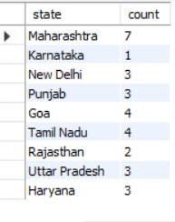

#Count the number of donors in each blood group:

SELECT blood_group, COUNT(*) AS count FROM donar GROUP BY blood_group;

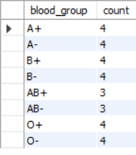

#List donors who donated in 2023 and are from Maharashtra:

SELECT donar_name, contactno,blood_group, state, date_0f_donate FROM donar WHERE YEAR(date_0f_donate) = 2023 AND state = 'maharashtra';

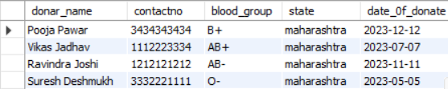

**#Get male donors older than 30:**

**SELECT donar_name, age, gender FROM donar WHERE gender = 'Male' AND age > 30;**

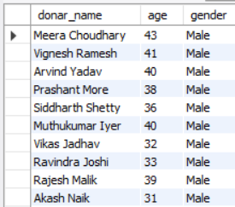

#Retrieve donors who have the same blood type as a specific receiver:

SELECT * FROM donar WHERE blood_group =

(SELECT blood_group FROM receiver WHERE receiver_id = 101);

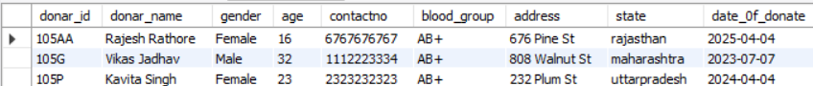

#Retrieve the names of receivers along with their respective donor names to receivers who want to received blood from donors in the same state.

SELECT receiver.receiver_name, donar.donar_name, donar.state, donar.contactno

FROM receiver

LEFT JOIN donar ON receiver.b_id = donar.donar_id

WHERE receiver.state = donar.state;

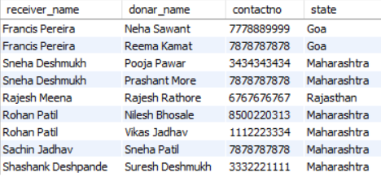

#Selecting receivers and their respective blood types from a specific state:

SELECT receiver.receiver_name, bloodtype.blood_type, receiver.state, bloodtype.blood_id

FROM receiver

INNER JOIN bloodtype ON receiver.b_id = bloodtype.blood_id

WHERE receiver.state = 'maharashtra';

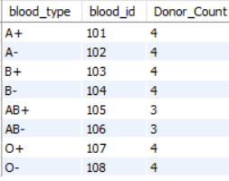

#Calculating the count of donors grouped by blood types:

SELECT bloodtype.blood_type,bloodtype.blood_id, COUNT(donar.donar_id) AS 'Donor_Count'

FROM donar

INNER JOIN bloodtype ON donar.blood_group = bloodtype.blood_type

GROUP BY bloodtype.blood_type;

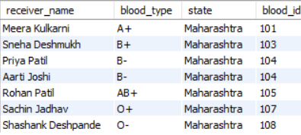

#Finding receivers and their respective blood types in a specific state with a blood type 'A+':

SELECT receiver.receiver_name, receiver.blood_group, receiver.state

FROM receiver

INNER JOIN bloodtype ON receiver.b_id = bloodtype.blood_id

WHERE receiver.state = 'new delhi' AND bloodtype.blood_type = 'A+';

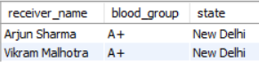

#Fetching donors along with their blood ids:

SELECT donar.donar_name, donar.blood_group AS 'Donor_Blood_Group', bloodtype.blood_id

FROM donar

INNER JOIN bloodtype ON donar.blood_group = bloodtype.blood_type;

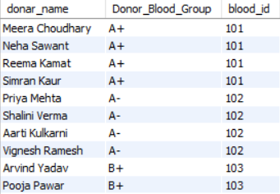

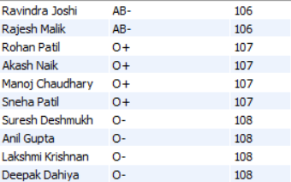

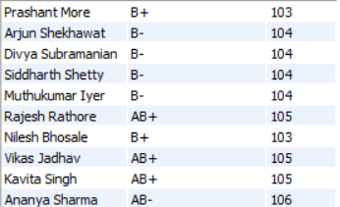

#Finding the count of receivers grouped by their blood groups:

SELECT bloodtype.blood_type, COUNT(receiver.receiver_id) AS 'Receiver_Count'

FROM receiver

INNER JOIN bloodtype ON receiver.b_id = bloodtype.blood_id

GROUP BY bloodtype.blood_type;

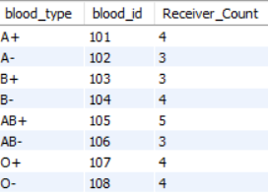

**Sub-queries**

#Retrieve the names of donors who have the same blood type as a specific receiver (e.g., receiver_id = 117).

SELECT *FROM donar WHERE blood_group= (SELECT blood_group FROM receiver WHERE receiver_id = 117);

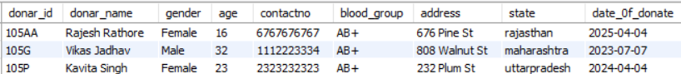

#Find the names of donors who are at least 10 years older than the youngest receiver.

SELECT donar_name, gender, age FROM donar

WHERE age> (SELECT MIN(age) + 10 FROM receiver);

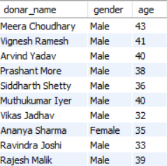

#Retrieve the count of male and female donors.

SELECT gender, COUNT(*) AS count_gender FROM donar

GROUP BY gender;

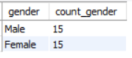

#List the donors who donated blood after the year 2023 in descending order of their ages.

SELECT donar_name, age, date_0f_donate FROM donar

WHERE YEAR(date_0f_donate) > 2023 ORDER BY age DESC;

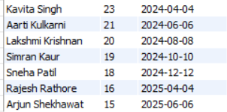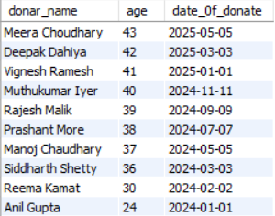

**CONCLUSION OF A PROJECT**

Blood bank database management encapsulates the achievements, outcomes, and implications of the implemented system.

"In conclusion, the development and implementation of the Blood Bank Database Management System have significantly improved the efficiency, reliability, and accessibility of vital information within our blood bank facility. Through meticulous planning and execution, the system has successfully addressed numerous challenges associated with blood inventory management, donor-recipients matching, and overall operational streamlining.

One of the primary accomplishments of this project is the establishment of a centralized and secure database that houses comprehensive information about donors, recipients, and blood inventory. This has facilitated quick and accurate matching of donors and recipients, ensuring timely access to compatible blood types and improving the overall response time in emergency situations.

The system's user-friendly interface has played a pivotal role in encouraging regular blood donations by providing donors with a convenient platform to schedule appointments, receive reminders, and track their donation history. Additionally, the implementation of security measures ensures compliance with data privacy regulations while safeguarding sensitive donor and patient information.

The successful integration of this system with existing healthcare infrastructure and its scalability features have positioned our blood bank for future growth and seamless collaboration with external stakeholders.

Overall, the Blood Bank Database Management System has significantly enhanced our ability to serve the community by ensuring a consistent and ample supply of blood, thereby contributing to the lifesaving mission of our organization. Moving forward, continued maintenance, periodic updates, and ongoing staff training will be crucial to sustaining the effectiveness and relevance of this system in meeting the evolving needs of our blood bank and the beneficiaries it serves."

Top of Form